**Experiment:-2**

**Aim:-** Draw the use case diagram and specify the role of each of the actors Also state the precondition, post condition and function of each use case for a given problem.

**1) Atm Machine :-**

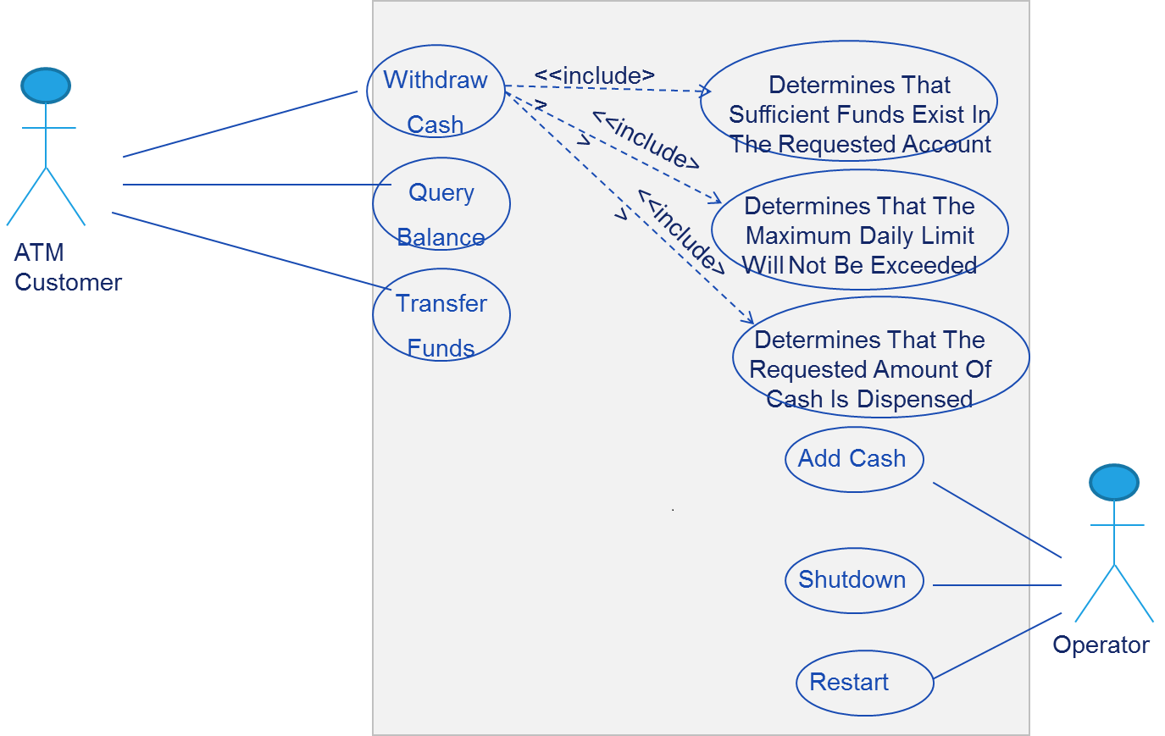

**Actor:-**

An actor is a person or a system that interacts with the system. A precondition is a condition that must be true before the use case can start. A post condition is a condition that must be true after the use case is completed. A function is a specific task that the system performs in response to the user's input.

**There are two main actors involved in an ATM machine:** the customer, the bank and the network. The customer is the person who wants to perform some transactions using the ATM machine, such as withdrawing cash, checking balance, transferring money, etc. The bank is the system that manages the customer's account and verifies the transactions. The network is the system that connects the ATM machine to the bank and other ATM machines.

The following are some of the use cases for an ATM machine and their corresponding roles, preconditions, post conditions and functions:

**Use case: Withdraw cash**

* **Actor:** Customer
* **Precondition:** The customer has a valid card and PIN, and there is enough cash in the ATM machine and in the customer's account.
* **Post condition:** The customer receives the requested amount of cash and a receipt, and the customer's account is debited by the same amount.
* **Function:** The ATM machine prompts the customer to enter the card and PIN, verifies them with the bank, asks the customer to enter the amount of cash to withdraw, dispenses the cash and a receipt, and updates the customer's account.

**Use case: Check balance**

* **Actor:** Customer
* **Precondition:** The customer has a valid card and PIN.
* **Post condition:** The customer sees the current balance of his or her account on the screen and optionally receives a receipt.
* **Function:** The ATM machine prompts the customer to enter the card and PIN, verifies them with the bank, displays the balance on the screen, and optionally prints a receipt.

**Use case: Transfer money**

* **Actor:** Customer
* **Precondition:** The customer has a valid card and PIN, and there is enough money in the customer's account and in the recipient's account.
* **Post** **condition**: The customer transfers a specified amount of money from his or her account to another account and receives a confirmation and a receipt, and both accounts are updated accordingly.
* **Function**: The ATM machine prompts the customer to enter the card and PIN, verifies them with the bank, asks the customer to enter the recipient's account number and name, asks the customer to enter the amount of money to transfer, confirms the transaction with the customer, sends the transaction to the bank, displays a confirmation message and prints a receipt, and updates both accounts.

**2) Online Shopping:-**

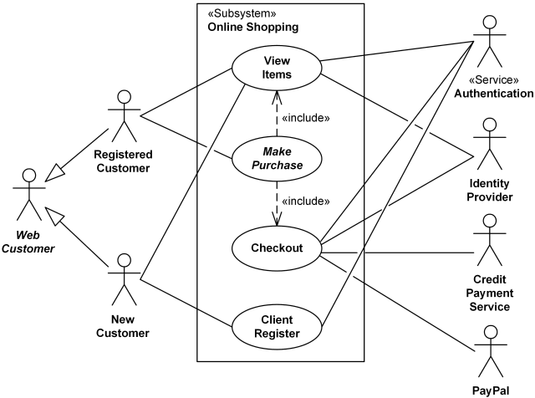

**3) Hotel Management System:-**

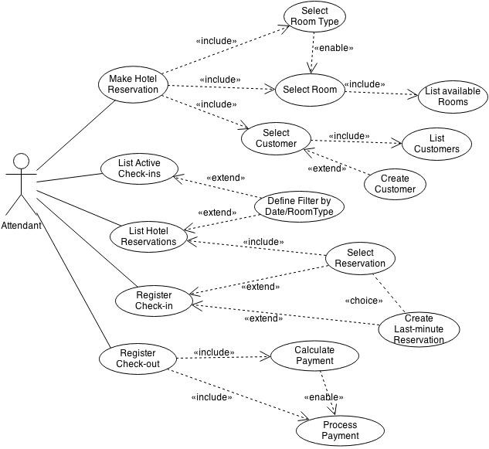

**4) library management system:-**

